Raymond A Christ

CREDENTIALS

Raymond A Christ Christ Appraisal Service, Inc (christappraisal.com)
W4100 Pheasant Run Tax I D > 39-1758004
Fond du Lac, WI 54935 Phone 920/922-8677 Fax 920/922-0377 Cell 920-960-7264

B S Business Administration - Finance
Marquette University, 1966
Wisconsin Certified Residential Appraiser #682 (10/92)
(30 years experience Real Estate Appraisal & Sales)
Wisconsin Licensed Real Estate Broker

Member Appraisal Section Wisconsin Realtors Association & National Association Realtors

Attended & completed Appraisal Certification Program of the Wisconsin Real Estate License Board - conducted by Wisconsin Realtors Association & The Appraisal Institute

Review Appraiser -City of Fond du Lac (1974-1978) Urban Renewal Neighborhood Development Program Community Development Block Grant Program

Real Estate/Real Property Consultant
Fond du Lac Wisconsin Area Economic Authority (1978-1996), Sweetwater Texas Industrial Development Corporation (1985-1988)

Author/Lecturer - Tax Increment Financing and Tax Abatement
Texas and Wisconsin 1982-96

Member Northeast Wisconsin Board of Realtors / MLS
Metro Association of Realtors / MLS
Green Lake Ripon Board of Realtors / MLS
Dodge County Board of Realtors / MLS

Member of Wisconsin Realtors Association / National Association of Realtors

Instructor/Trainer Wisconsin Real Estate License Board
(Pre-License, Broker Management, Continuing Education
@ Moraine Park Technical College @ Lakeshore Technical College
@ Wisconsin Realtors Association

GRI - Graduate REALTOR Institute

Industrial Development Institute - 2 year Certificate (1974-76)
American Economic Development Association

VA Fee Appraiser Panel
FHA Approved National Lender Selection List

Speaker -Housing Market and Trends, Investment Analysis, Buyer Brokerage, First Time Home Buying

Attended numerous seminars on Real Estate, Relocation, Facility Location, Valuation and Statistical Analysis. (1972-01)

APPRAISAL ACTIVITY AREA (Wisconsin Counties of) All of Fond du Lac, Sheboygan, Dodge, Calumet, Winnebago, Green Lake. Parts of Washington, Waushara, Manitowoc, Marquette, Outagamie

MARKET & DATA SOURCES

Multiple listing services, Area homebuilders, Area title companies, REALTOR connections, Computerized Data Base developed since 1981, Resource connections at government centers from past work connections.

COMMUNITY INVOLVEMENT

Member Fond du Lac County Economic Development Corporation, Past President Fond du Lac Multiple Listing Service, Member Board of Realtors Ethics/Professional Standards Committee and Secretary/Treasurer of Board (1994-95), Realtors Assocaition of Northeast Wisconsin Appraisal Committee Chairman 2000/2004.

PROFESSIONAL & TECHNICAL COURSES - Appraisal

Basics of Appraisal April 1992 Wisconsin Realtors
Real Estate Analysis April 1992 Wisconsin Realtors
Sales Comparison Approach May 1992 Wisconsin Realtors
Cost/Income Approach May 1992 Wisconsin Realtors
Appraisal Ethics May 1992 Wisconsin Realtors
Annual Appraisal Continuing Education – 1992 / 2004 > 28+ hours per year (through Realtors or Appraisal Institute)

REFERENCES (CLIENTS)
U S BANK, WELLS FARGO, FOX VALLEY SAVINGS BANK, M & I MORTGAGE, BANK ONE, AMERICAN BANK,
WASHINGTON MUTUAL, COUNTRY WIDE HOME LOANS, NATIONAL EXCHANGE BANK, BANK AMERICA, BANK
MUTUAL, PRUDENTIAL RELOCATION, ASSOCIATED MORTGAGE, CITIZENS FIRST CREDIT UNION, ANCHOR BANK,
LENDERS SERVICE, VALUE IT, RES DIRECT, STATE FARM, CHASE MANHATTAN, FOND DU LAC COUNTY, CITY OF
FOND DU LAC, FOND DU LAC SCHOOL DISTRICT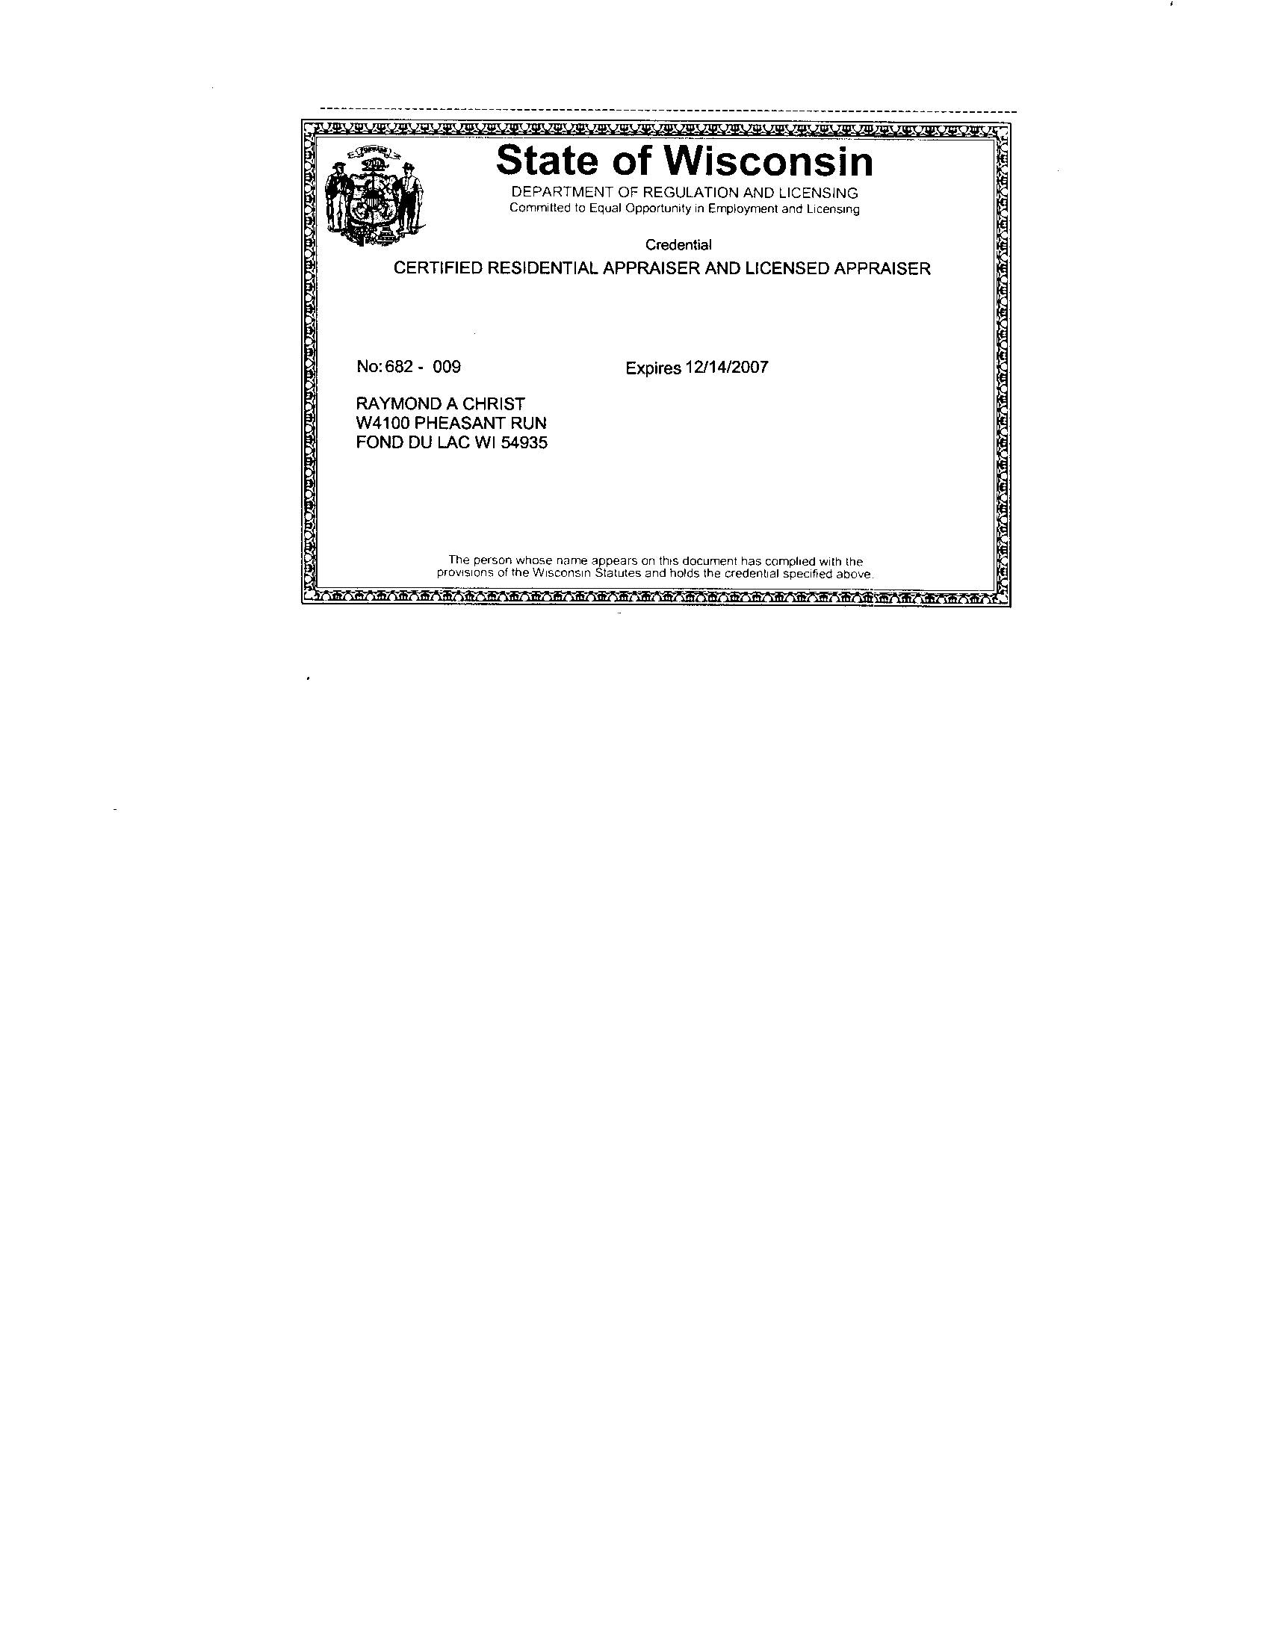

CREDENTIALS

Timothy A Christ Christ Appraisal Service, Inc
N6144 Eleanore Lane 920-922-8677 Phone
Fond du Lac, WI 54935 920-922-0377 Fax

Wisconsin Licensed Appraiser #1037
Licensed for all residential

High School Graduate - 1986
Sweetwater Texas High School

Texas State Technical Institute (1986-87)
(Technical Trades)

Attended & completed Appraisal Certification Program of the
Wisconsin Real Estate License Board - conducted by
Robbins & Lloyd Appraisal School

Basics of Appraisal

Estate Analysis

Sales Comparison Approach

Cost / Income Approach

Uniform Standards of Professional Practice

1996/2004 Wisconsin continuing education – 28+ hours Bi-Annually

Challenged & passed Wisconsin Appraiser License Examination (12-96)

Appraiser - Christ Appraisal Service (Sep 1995 –Present)

Member
Realtors Association Northeast Wisconsin
Wisconsin Realtors Association

APPRAISAL ACTIVITY AREA (Wisconsin Counties) Fond du Lac, Dodge, Calumet, Winnebago, Green Lake, Sheboygan, Washington, Manitowoc, Waushara, Marquette

MARKET & DATA SOURCES

Multiple listing services, Area homebuilders, Area title companies, REALTOR connections, Computerized Data Base developed since 1981, Resource connections at government centers from past work connections.

EXPERIENCE REFERENCES

National Exchange Bank - Bob Berryman, Vice President; 130 S Main St, Fond du Lac, WI 54935, 920/921-7700

American Bank Fond du Lac – Jed Keller, Vice president; 888 S Main, Fond du Lac, WI 54935, 920/929/9292

Hometown Bank – Erv Karls, Vice President; 245 N Peters Av, Fond du Lac, WI 920/907-2220
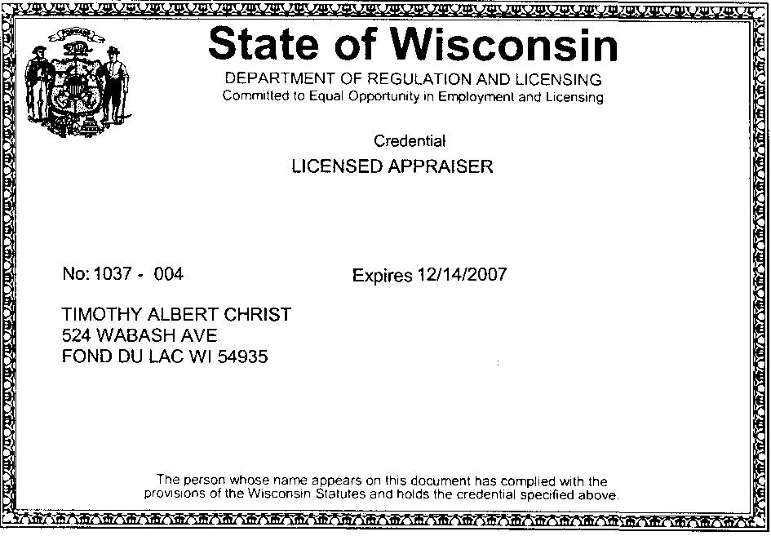

CREDENTIALS

Terrence R Christ Christ Appraisal Service, Inc
W7081 Forest Av 920-922-8677 Phone
Fond du Lac, WI 54935 920-922-0377 Fax

Wisconsin Licensed Appraiser #1313

High School
Fond du Lac Goodrich High School

Moraine Park Technical College
(Computer Technician)

Attended & completed Appraisal Certification Program of the
Wisconsin Real Estate License Board - conducted by
Robbins & Lloyd Appraisal School

Basics of Appraisal

Estate Analysis

Sales Comparison Approach

Cost / Income Approach

Uniform Standards of Professional Practice

Challenged & passed Wisconsin Appraiser License Examination (06/00)

2000/2004 Wisconsin continuing education – 28+ hours Bi-Annually

Appraiser - Christ Appraisal Service (Sep 1997 –Present) (Has completed more than 3,000 appraisals)

Member
Realtors Association Northeast Wisconsin
Wisconsin Realtors Association

APPRAISAL ACTIVITY AREA (Wisconsin Counties) Fond du Lac, Dodge, Calumet, Winnebago, Green Lake, Sheboygan, Washington, Manitowoc, Waushara, Marquette

MARKET & DATA SOURCES

Multiple listing services (four area data bases), Area homebuilders, Area title companies, REALTOR connections, Computerized Data Base developed since 1981, Resource connections at government centers from past work connections.

EXPERIENCE REFERENCES

National Exchange Bank - Bob Berryman, Vice President; 130 S Main St, Fond du Lac, WI 54935, 920/921-7700

American Bank Fond du Lac – Jed Keller, Vice president; 888 S Main, Fond du Lac, WI 54935, 920/929/9292

Hometown Bank – Erv Karls, Vice President; 245 N Peters Av, Fond du Lac, WI 920/907-2220

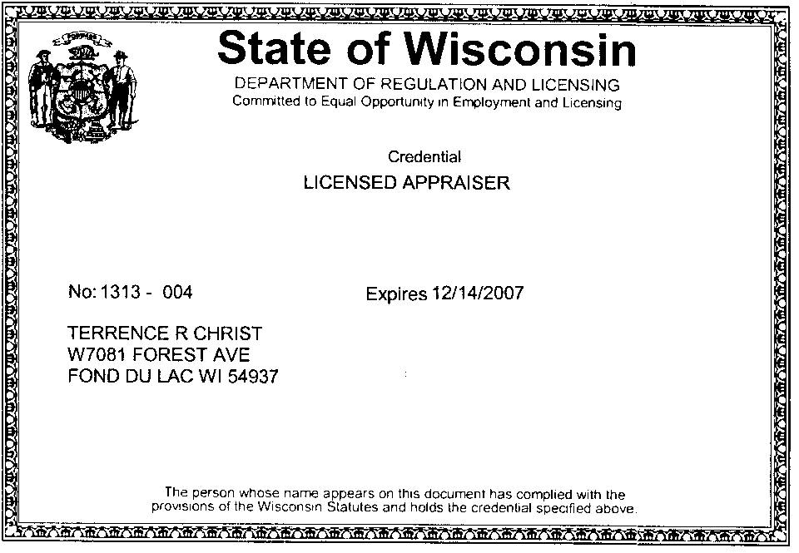

CREDENTIALS

Anne M Christ Christ Appraisal Service, Inc
N7267 Winnebago Dr 920-922-8677 Phone
Fond du Lac, WI 54935 920-922-0377 Fax

Wisconsin Appraiser Trainee

High School
St Mary’s Springs High School

Attended & completed Appraisal Certification Program of the
Wisconsin Real Estate License Board - conducted by
Madison Area Technical College

Basics of Appraisal

Estate Analysis

Sales Comparison Approach

Cost / Income Approach

Uniform Standards of Professional Practice

Appraiser - Christ Appraisal Service (Sep 1998 –Present)

Member (Associate)
Realtors Association Northeast Wisconsin
Wisconsin Realtors Association

APPRAISAL ACTIVITY AREA (Wisconsin Counties) Fond du Lac, Dodge, Calumet, Winnebago, Green Lake, Sheboygan, Washington, Manitowoc, Waushara, Marquette

MARKET & DATA SOURCES

Multiple listing services (four area data bases), Area homebuilders, Area title companies, REALTOR connections, Computerized Data Base developed since 1981, Resource connections at government centers from past work connections.

